#### **SETUP FOR RUNNING THE APPLICATION**

#### **1. Reddit API Setup**

* Visit:<https://old.reddit.com/prefs/apps/>
* Follow the visual steps:  
  + 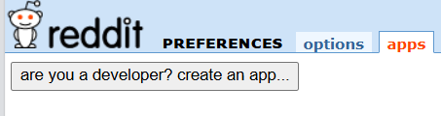
  + 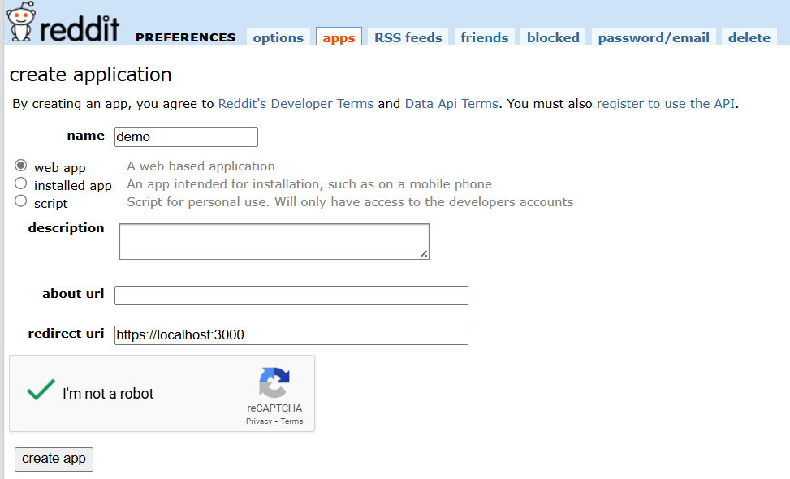
  + 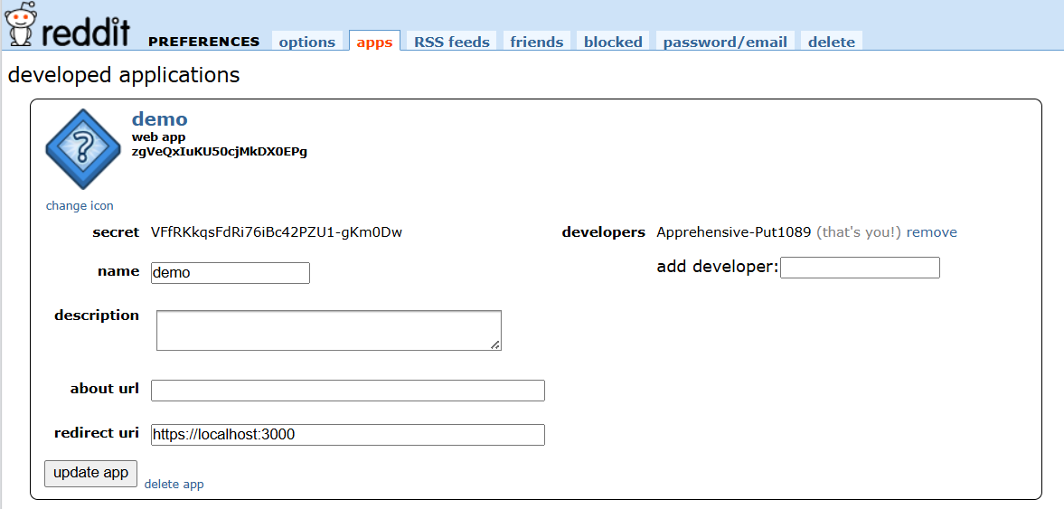

#### **2. Google API Key for Gemini**

* Visit:<https://aistudio.google.com/apikey> Create and save your Google API Key.

#### **3. Twitter (X) Bearer Token**

* Visit:<https://developer.x.com/en/portal/dashboard>
* Steps:  
  + Create a profile on X
  + 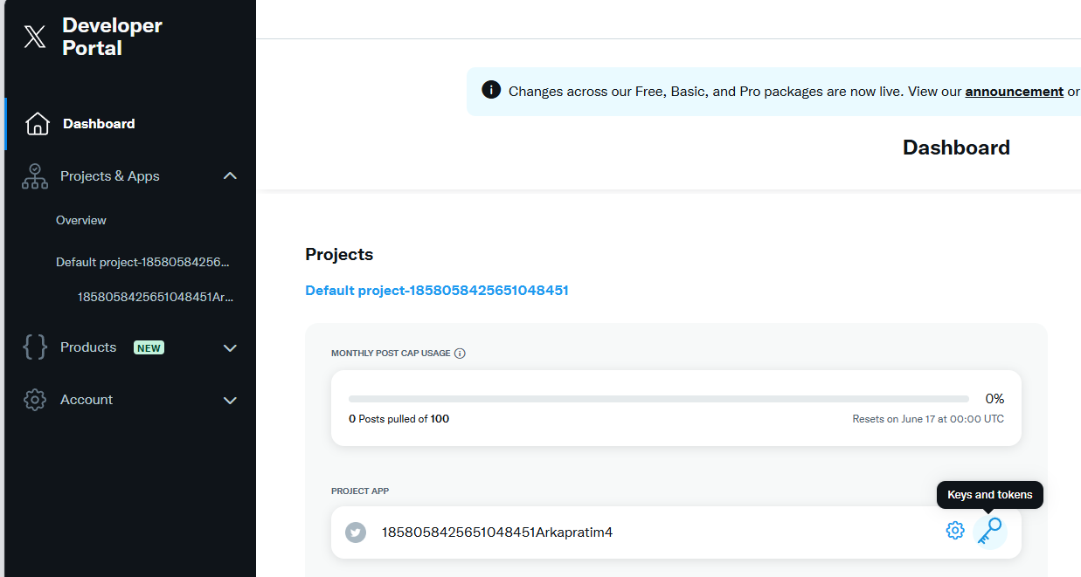
  + 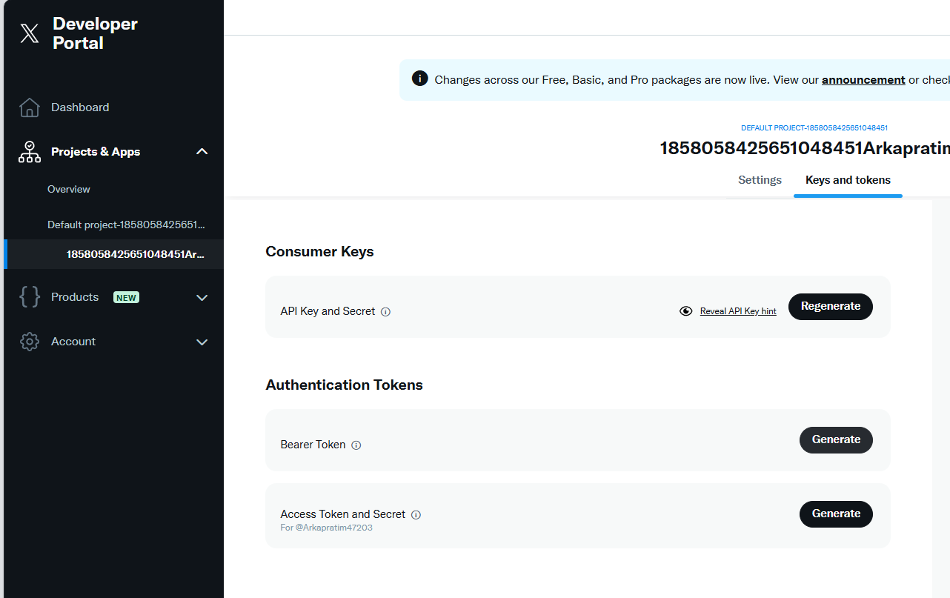

#### **4. Ngrok Setup**

* Visit:<https://ngrok.com/>
* Login with GitHub and follow the steps:  
  + 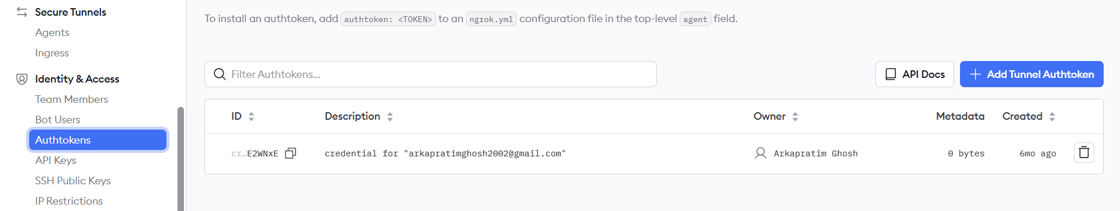
  + 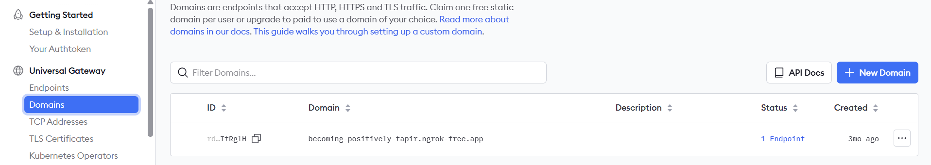

### **5. Download Required Files (Actual URLs)**

1. **Pickles and Required Files**<https://drive.google.com/uc?export=download&id=1LguxWEB64xMTUtJ46tKPhQzZ37jGZilV>
2. **Notebook (WebAppV13-7.ipynb)** [https://drive.google.com/uc?export=download&id=](https://drive.google.com/uc?export=download&id=1rCKbEAwJvjPJJICKXNYOGxI6GVJQ7kPC)1Qvnoh1e7AbWs-xFml_xcRQ_FIg4NPPZa
3. **Sample Data**<https://drive.google.com/uc?export=download&id=1VH3QKcllymxj3CSeRkWBe9XbN0PTrvs8>

#### **6. Regenerate cross_encoder_gpu.pkl (if needed)**

from sentence_transformers import CrossEncoder

import pickle

cross_encoder_model = CrossEncoder('cross-encoder/ms-marco-MiniLM-L-6-v2', device='cuda')

with open("cross_encoder_gpu.pkl", "wb") as f:

pickle.dump(cross_encoder_model, f)

print("✅ Saved cross_encoder_model to pkl")

Replace the old cross_encoder_gpu.pkl file in the folder with this one if there's a Colab environment compatibility issue.

### **7. Start the Application**

**Watch the demo or launch guide:** <https://drive.google.com/file/d/1LSSzi3sttacXlVt146ebSsmWp4bq9lbc/view>

### **8. View Sample Reports Folder**

**GitHub Reports Folder:** <https://github.com/arkapg211002/MAFSMBMDDPWI-FYP-2025/tree/main/WEB%20APP%20REPORTS>